The project will be optimised for mobile and the application will respond to different screen sizes. We have identified the following requirements for the project.

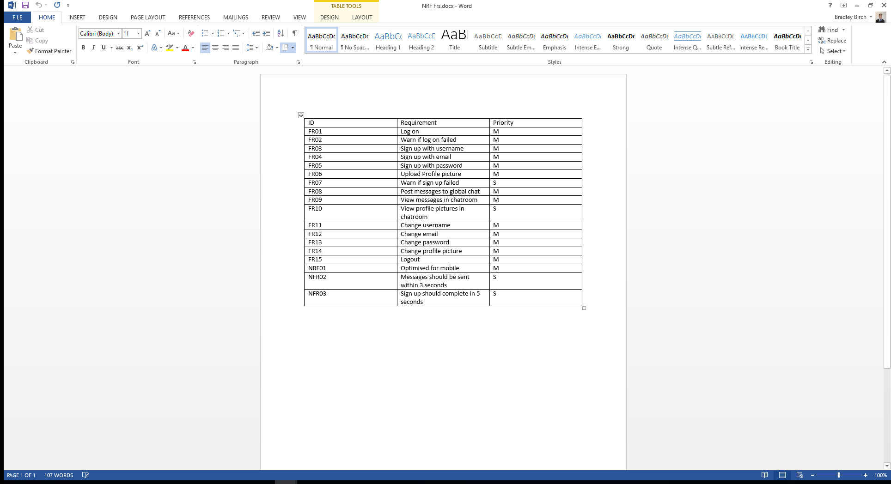

Figure : Project requirements

With these requirements in mind, we have created the following designs.

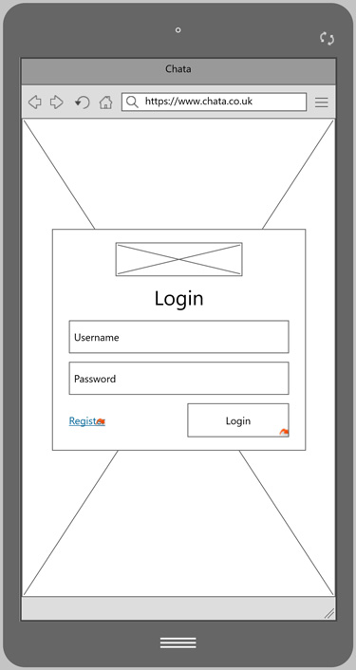

* Minimal input so that virtual keyboard does not cover any fields
* Validation will colour the input box and a message will occur above the fields
* Button to navigate to the sign up screen
* Large call to action button to login

Figure : Login screen

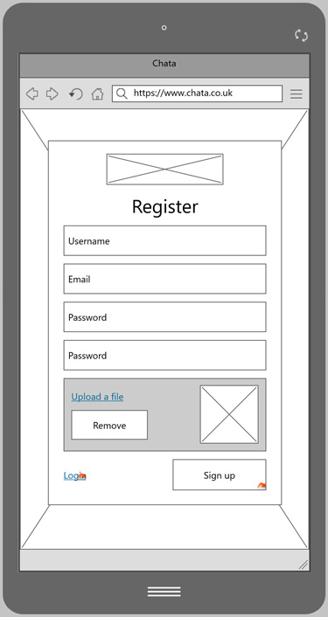

* Minimal fields to sign up
* Password confirmation box
* Validation will colour the input box and a message will occur above the fields
* Button to navigate to the login screen
* Large call to action button to sign up

Figure : Register screen

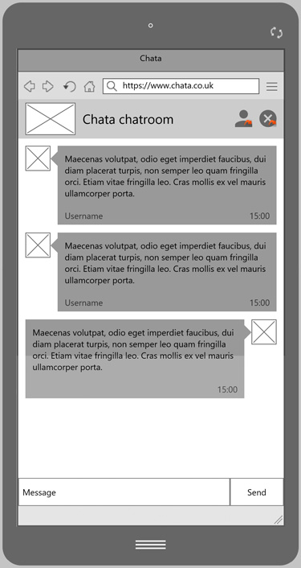

* Top inline navigation bar takes you to profile page and logout
* Clean page with little clutter allows for an easy user experience
* Users can see the profile pictures of different users
* Clear input and send button
* Message failure message will occur as a pop up above the send message

Figure : Chatroom screen

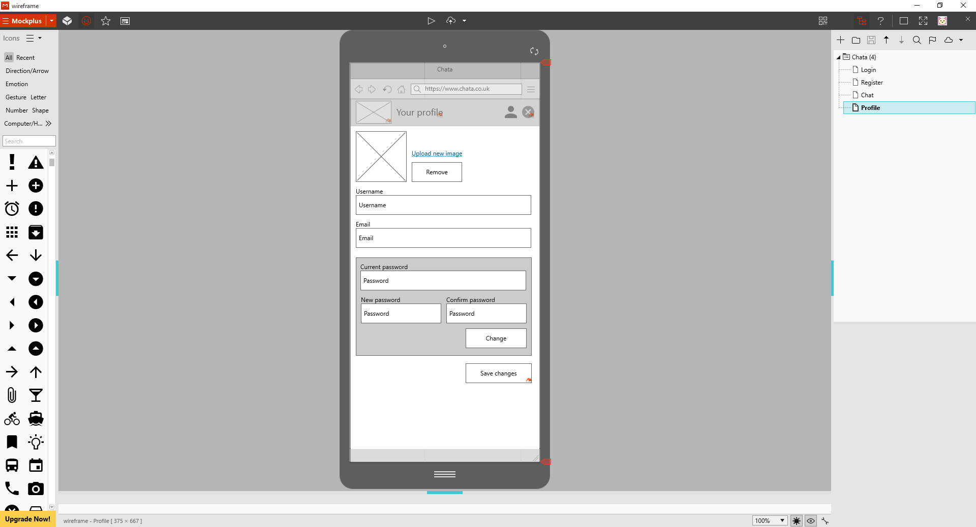

* Top inline navigation bar takes you to chat and logout
* Validation will colour the input box and a message will occur above the fields
* Save will return you to the chat room
* Minimal amount of fields